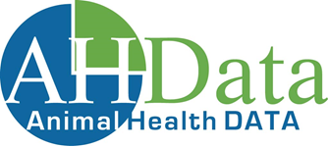
Animal Health Data
ABN 55 065 153 540
E: data@animalhealthdata.com.au
M: 0429 023 889
W: www.animal-health-data.net.au

MSA Authorisation Form

[Date]

The Manager
Animal Health Data
177 Bennetts Road,
NORMAN PARK QLD 4170
data@animalhealthdata.com.au

I, [NAME], as the Authorised Representative for [FEEDLOT] provide authorisation for Animal Health Data to access the MSA database on behalf of [FEEDLOT] for the limited and exclusive purpose of data analysis within the Animal Health database.

The data obtained from the MSA database related to [FEEDLOT] shall not be provided to any third party by Animal Health Data without my written authorisation.

Signed: ____________________________ of [FEEDLOT]. Date: ____/____/2019

